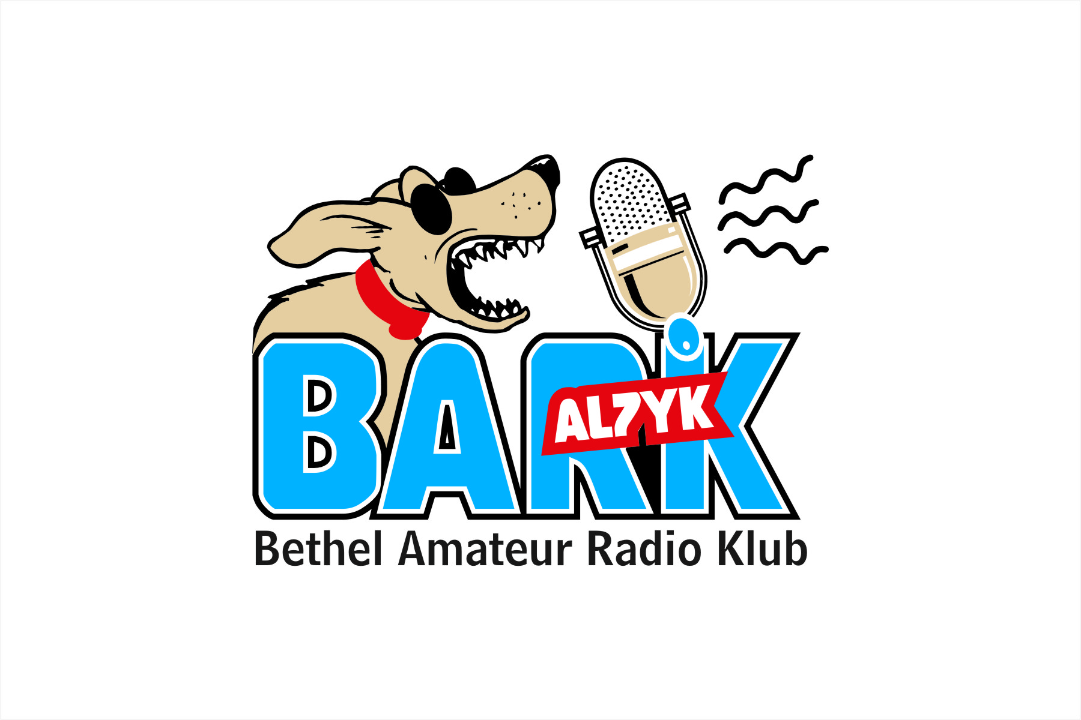 2/6/08
Bethel Amateur Radio Klub
Monthly Meeting for February 2008

Attendance:
Joe Seibert, AL1F
Ken Eggelston, NL7SP
Bruce Perry, KL7NZ
Allen DeSousa, KL2AU
Richard Dennis, KL7IOL
Will Johnson, KL7KT
Jerry Johnson, KL2JA

Notes:

1. No agenda. President Springer, WL7BCT, is out of town on business.

2. Discussion of K300 coverage. NL7SP reviews coverage and asks for suggestions for improvements for next year:
A. Better communications between club members. Email notices to all members. This brought up discussion of who are members. Do we have “official” members because the club has not yet incorporated?
B. Check snow machine performance/maintenance further ahead of time. KL2JA discovered his snow machine would not run a few days before the race. KL2IS also discovered snow machine failure right before the race.
C. KL7KT suggests purchasing a lightweight. push-up mast for the remote antenna. KL2JA describes how one section of the mast broke this year.
D. AL1F suggests installing a vertically polarized yagi antenna pointed up-river to increase signal/noise ratio on weak signals.
E. Discussion of potential Kalskag repeater. AL1F states he will be meeting with Dave Heimke of UUI on 2/11 and will further discuss potential repeater at Kalskag CO.

3. NL7SP states he has been contacted by teacher in Tuluksak about getting a ham radio class together for students.

4. Discussion about testing and training. NL7SP states he requested test kits for VEC just before the K300 weekend. He followed request with email and phone call, still has not received test kits at this time. He will be heading into Anchorage soon and will go by and pick them up if need be.
Discussion follows about potential training session in late March. AL1F is tasked with identifying dates that will not interfere with other events in town. Al1F will begin to advertise and at the next club meeting instructors will be identified. AL1F will order new W5YI books for students and Instructors.
NL7SP suggests we have a pre-class on the Tuesday before. This would enable us to knock out the intro sessions and allow for more test time on the final Sunday. This meeting could serve as registration too. Students would also be allowed to register at KYUK anytime before the class starts.
KL7IOL states his school will have room available for classes. KL2AU states that ME would probably be willing to donate classroom space again.
Potential students- Jody Malou, Jolie Morgan, Tom McCaulson, Star from BABs. Potential Instructors: AL1F, KL7IOL, KL2AU, KL7NZ, N5RMJ, WL7BCT, KL1VA. KL7KT and NL7SP might be unavailable during March. VE’s available- AL1F, WL7COJ, N5RJM.

5. Meeting adjourned by AL1F.

